activity 9

memorization

directions
Have one group member upload this docx file to your Google Drive and share it with your groupmates and your instructor. Name your document “GroupX_Activity9” (where X is your group number). Work together to type up your responses to each question. Download your document as a PDF and submit this to Canvas individually.

BACKGROUND
Many times during the term, you may feel like your brain just cannot hold all of the information you are learning in your classes. Are there ways to improve our memories so that we can comprehend even more information? Research in cognitive psychology has suggested that the answer to that question is a resounding “yes”. This literature has suggested several strategies to improve memory, enhance recall, and increase retention of information.
One of the strategies identified by cognitive psychologists is that of chunking. Chunking refers to the process of taking individual units of information and grouping them into larger units (chunks). One common example of chunking occurs when we write and recall phone numbers. For example, a sequence of digits in a phone number, say 8-6-7-5-3-0-9, would be chunked into 867-5309.
In this activity, our class will perform an experiment and use the data collected to explore the following research ​​​​question:
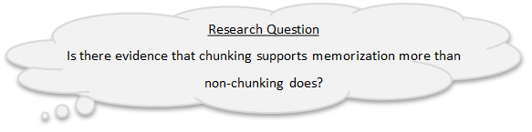

the memory experiment
- Now, while you are waiting for the data to be compiled and sent out to the class, let’s review some terminology. The first part of any analysis is to examine the observed data. These are the data that are actually observed in the research study, unlike data that is simulated in TinkerPlots. In this study, we have data on two attributes for each participant in the study. What are the two attributes (two pieces of information or variables) we have about each participant?

Check your thinking:
The first attribute we have information about is the participant’s score (i.e., the number of letters recalled) from the memory experiment. This is called the response variable since it contains data on the subjects’ responses to the experiment.
The second attribute we have information about is the treatment condition that the subject was assigned to. This is called a treatment variable or grouping variable. In this research study the two levels of the treatment variable (the two conditions) are the experimental condition (chunking) and the control condition (no chunking).

- Is the treatment/grouping variable quantitative (numerical) or categorical? Was this the case in the past two activities (Dolphin Therapy and Blood Donations)? Will this type of variable always be the selection you chose?

- Is the response variable quantitative (numerical) or categorical? Was this the case in the past two activities (Dolphin Therapy and Blood Donations)? Will this type of variable always be the selection you chose?

Hopefully, the data will be available to you and your classmates now! Once it is, open that data in TinkerPlots and follow the instructions below to complete question 4.
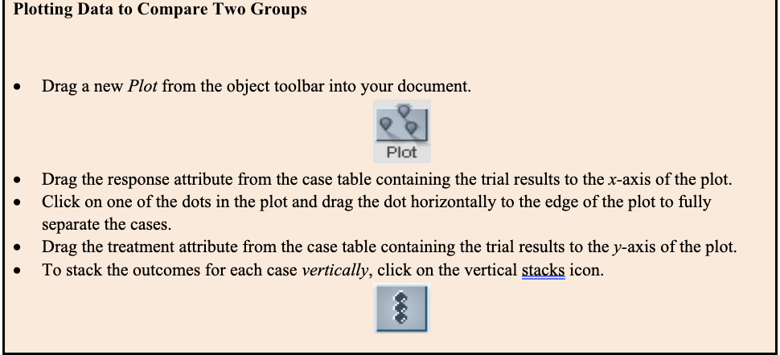
- Using the TinkerPlots file with your class’s results, create a plot to compare the two conditions (directions provided directly above) and then answer the following questions:

- Paste the plot below.

- Interpret what a dot in each of the plots represents. Be specific and give an interpretation for one of the dots in the plot.

- Look at the plots you constructed based on your classroom data.
- What do you notice about the two plots?

- Describe any differences or similarities between the two plots.

- Based on the scores in the two plots, does it seem like there is an effect of chunking letters on memory (in other words, does it seem like the scores are higher for the chunking group than for the non-chunking group)? Explain.

summarizing the different between the two conditions
In order to answer the research question, you need to summarize the difference between the treatment and control conditions using a single number.
When the response variable is quantitative, it is conventional to do this by finding the mean value of the response variable for each condition, and then compute the difference between the two means. The difference in means satisfies the need for a single number summary. It also has another very nice quality, namely that the difference in means is interpretable. The difference in means indicates how much better (or worse) the typical subject in the treatment condition does than a typical subject in the control condition.

- Use TinkerPlots to compute and record the mean score for each of the two conditions.

- Compute and record the difference in means by subtracting the mean score for the non-chunking condition from the mean score for the chunking condition. (Note that this difference is the difference in means for the observed data because we used the data from our class experiment to compute it).

- Interpret this difference using the context of the memory study.

We can also use the Ruler Tool in TinkerPlots to help us compute the difference in means for our observed data.

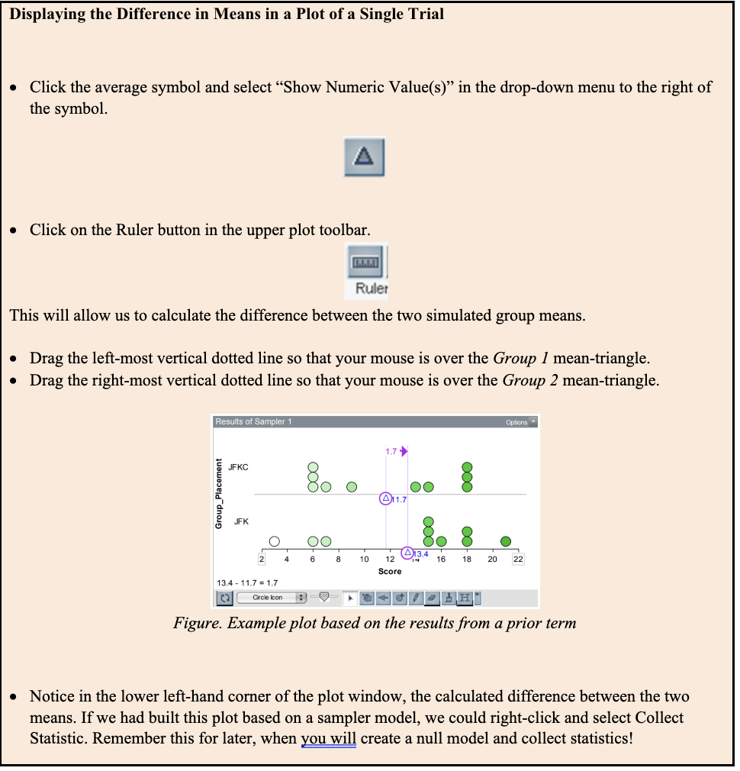
- Use TinkerPlots to compute and report the difference in the observed mean scores for the two conditions (see directions directly above). Did you get the same value as you did when you made the computation by hand (Question 6)?

- Before you conclude that chunking has an effect on memory, consider another alternative: the difference in means you saw in the observed data is solely attributable to experimental (chance) variation. Under this assumption, the difference in means is not because of chunking words, but rather because the random assignment to conditions/groups introduces variation into the results. If there is not an effect of chunking on memory, what would you expect the difference in means to be? Explain.

​​​​​
The “no group differences” model
To examine whether a result obtained in the observed data is solely due to chance (i.e., all the variation is due to random assignment), one approach is to imagine the scenario under which there is no difference in scores for the participants in the chunking and no chunking groups. In this particular context, assuming there is no group difference is the same as assuming chunking had no effect, whatsoever. Under this assumption or scenario, evidence would be collected to determine if the difference in means that was observed in the data is too large to probabilistically believe that there is no effect of chunking.
If chunking is truly ineffective, then each subject’s score on the memory test is only a function of that person and not a function of anything systemic, such as chunking. The implication of this is that, had a subject been assigned to the other condition (through a different random assignment), their score on the memory test would have been identical, in a sense, both conditions are doing nothing in terms of affecting the memory test scores.

- Write out statements for what you think the null hypothesis and the researcher’s hypothesis would be.

calculating the randomization test using tinkerplots
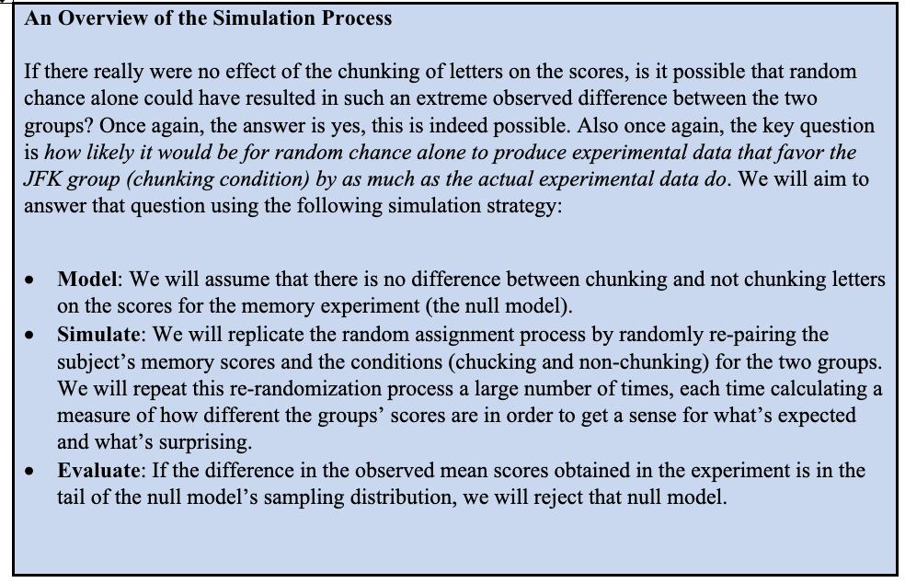
- Discuss in your group how you might construct a null model in TinkerPlots that will allow you to simulate data to answer the research question of interest. Set-up a TinkerPlots sampler that reflects your discussion.

As part of your work, be sure to:

- Copy and paste a picture of your TinkerPlots sampler below.

- Describe why you set the model up the way you did. In particular, please discuss how the model you constructed incorporates the ​​​​assumption made in the null ​​​​hypothesis (see Question 10) AND the random process that the researchers conducted.

- State what the repeat and draw values are set to and explain why they are set to those values.

- Describe what elements you used to populate the device(s) in your sampler and why.

- Describe if the device(s) in your sampler are set to with or without replacement and explain why.

- What labels did you give the attribute(s) in your model? What do those label(s) represent/mean to you?

- Write out a brief description of the simulation process for each of the key parts of the randomization study:

- Describe what is happening when you run a single trial of the simulation and how this relates to the problem context.

- Run a trial of the simulation and make a plot of your output. Use the Ruler Tool to construct the difference in mean scores between the chunking and non-chunking groups. Paste your plot below.

- Interpret what a dot in the plot represents.

- Use TinkerPlots to simulate the results of 500 trials and collect statistics on the difference in mean scores between the chunking and non-chunking group. (Note: If you used the ruler tool to compute the mean difference from one trial of the simulation you can select the value of the mean difference in your plot with your cursor and collect directly on that value).

- How does collecting statistics on the difference in the mean scores help with answering the research question? Would it make sense in this case, to only collect statistics on the mean score for the chunking group? Why or why not?

- Construct a plot of the sampling distribution. Copy and paste the plot of the sampling distribution below.

- Describe what a dot in this plot represents.

- Where is the center of the sampling distribution located? In light of the assumptions that you made when constructing your model (see Question 11b), does this make sense? Why or why not?

- ​​​​​Based on the difference in the observed mean scores for the class experiment (Problem 6 or 8), what is the p-value? Please describe what the p-value means in the context of this problem.​

- Based on your response to Question 14, how strong is the evidence against the null model? What does this suggest about the answer to the research question?

